EX NO: 4 | Configure SMTP and FTP protocols using Packet Tracer
DATE:04/08/26

Objectives
- To configure and test email communication between networked devices using the SMTP protocol and verify successful message delivery through a mail server.
- To configure and test file transfer operations between a client and a server using the FTP protocol and verify successful file upload and download.

Software/Apparatus required:
  - Cisco Packet Tracer
  - End Devices (PCs)
  - Switches
  - Copper Straight-through Cable / Automatic Cable Selector
  - Routers
  - Server (Email server or FTP Server)

Procedure
Objective 1: SMTP Protocol
    - Create the network topology using two PCs, switches, a router, and a server in Cisco Packet Tracer.
    - Configure the necessary network settings on all devices and ensure that the router interfaces are enabled.
    - Verify connectivity between the PCs and the server using the ping command.
    - Open the server configuration window and enable the SMTP and POP3 services.
    - Create email accounts for the users on the server by specifying usernames and passwords.
    - Open the Email application on each PC and configure the email account details, including the email address, username, password, and mail server information.
    - From the sender PC, compose a new email by entering the recipient’s email address, subject, and message content.

    - Click Send to transfer the email to the mail server using the SMTP protocol.
    - On the recipient PC, open the Email application and click Receive to retrieve the email from the server using the POP3 protocol.
    - Verify that the email is successfully received in the recipient’s inbox.
    - Repeat the process with different users, if required, to confirm successful email communication.

Objective 2: FTP Protocol
- Create the network topology using PCs, switches, a router, and an FTP server.
- Configure the network settings and verify connectivity between the client PC and the FTP server.
- Enable the FTP service on the server and create the required files.
- Open the Command Prompt on the client PC and connect to the FTP server using ftp
<Server_IP_Address>.
- Display the files available on the server using dir.
- Download a file from the server using get sample.txt.
- Verify the downloaded file using dir.
- Upload a file from the client PC to the server using put report.txt.
- Display the updated file list using dir.
- Close the FTP session using quit.
- Verify that the file transfer operation was completed successfully.

Network Diagram Objective 1: SMTP Protocol

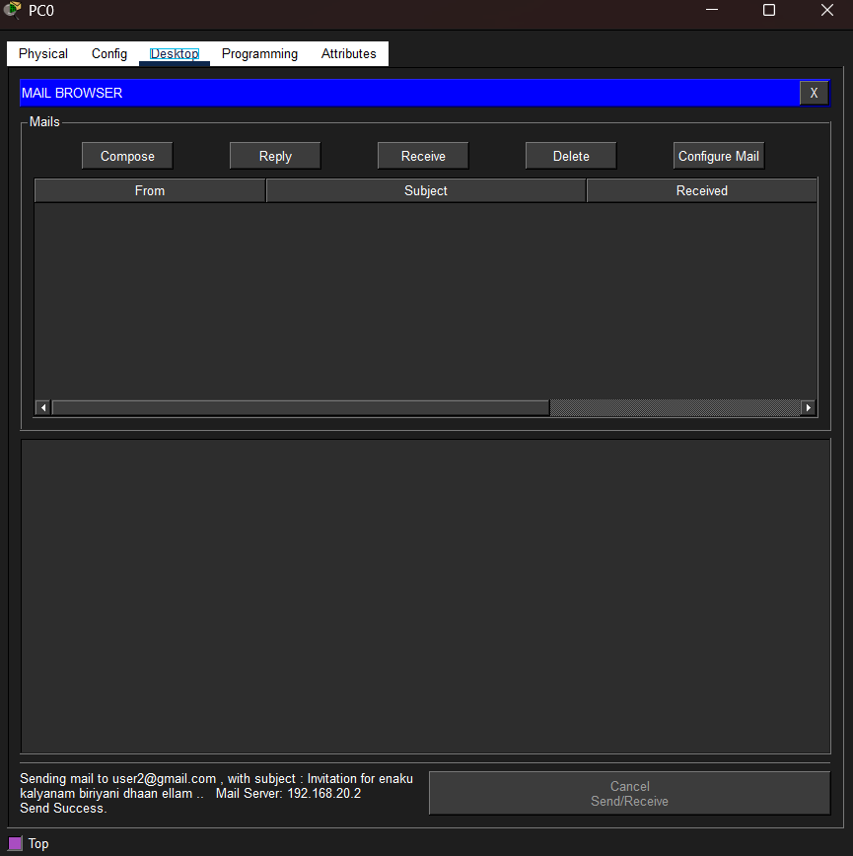

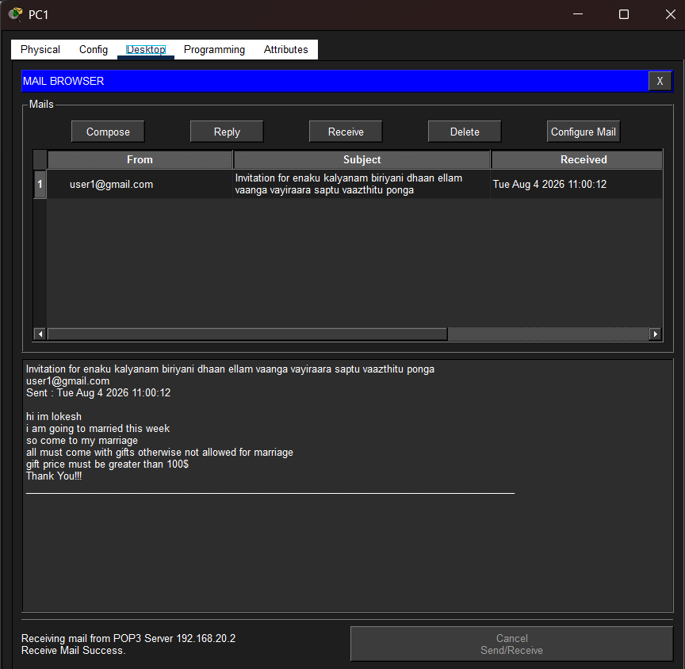
Objective 2: FTP Protocol

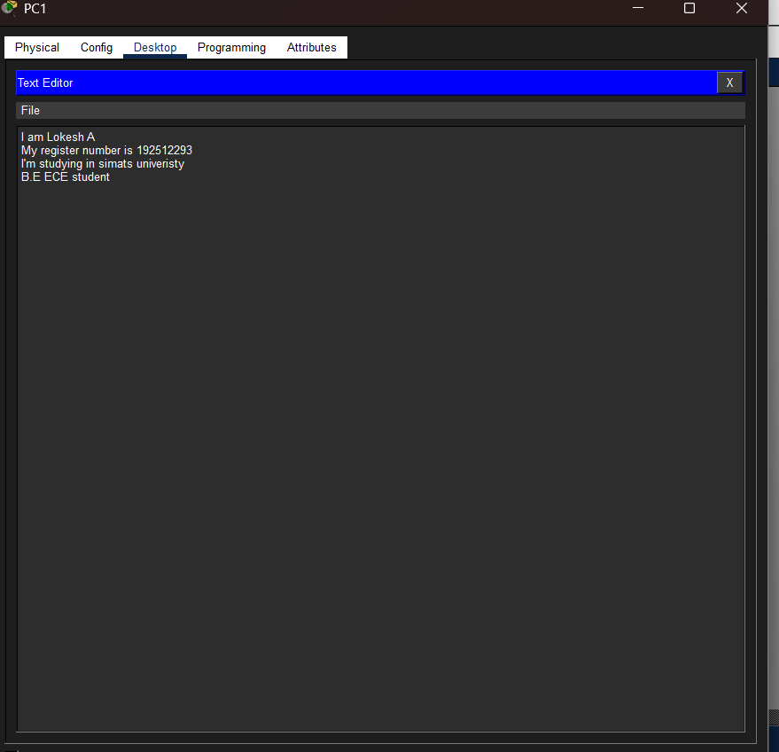

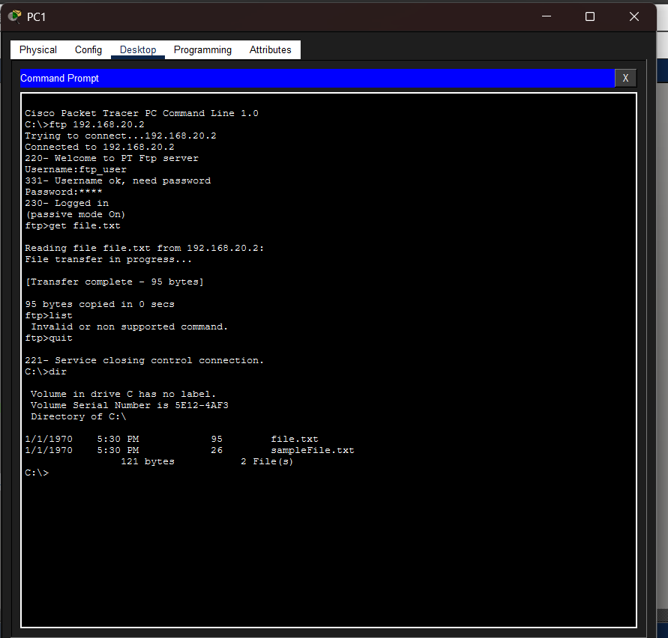

Output
Objective 1: SMTP protocol

From address | To address | Message

Composed Email output

Received Email output

Objective 2: FTP protocol

Username 1 | Password 1 | Username 2 | Password 2 | File shared

Result
Objective 1: SMTP Protocol
- Email communication was successfully established, and email messages were transmitted and received correctly through the mail server using SMTP.

Objective 2: FTP Protocol
- File transfer was successfully established, and files were uploaded to and downloaded from the FTP server using the FTP protocol.

Test case Question 1
Implement the specified SMTP topology using Cisco Packet Tracer and analyze email communication between client devices through a mail server.
Case 1
  - Number of PCs: 2
  - Number of Switches: 1
  - Number of Routers: 1
  - Number of Mail Servers: 1
  - Services Enabled: SMTP and POP3 Case 2
  - Number of PCs: 4
  - Number of Switches: 2
  - Number of Routers: 1
  - Number of Mail Servers: 1
  - Services Enabled: SMTP and POP3
  - Inter-switch Connection: Switch-to-Switch Link Tasks
- Construct the specified topology and configure the mail server with SMTP and POP3 services.
- Create email accounts for all users and configure the email clients on the PCs.
- Send and receive email messages between users and verify successful email communication.

Aim (10) | Networking Diagram  (30) | Procedure (10) | Results (20) | Record (10) | Viva (20) | Total (100)

Test case Question 2

Implement the specified FTP topology using Cisco Packet Tracer and analyze file transfer operations between client devices and an FTP server.
Case 1
  - Number of PCs: 2
  - Number of Switches: 1
  - Number of Routers: 1
  - Number of FTP Servers: 1
  - File Transfer Mode: Client–Server Case 2
  - Number of PCs: 4
  - Number of Switches: 2
  - Number of Routers: 1
  - Number of FTP Servers: 1
  - File Transfer Mode: Client–Server
  - Inter-switch Connection: Switch-to-Switch Link Tasks
- Construct the specified topology and configure the FTP server with user access and files.
- Establish FTP connectivity between the client PCs and the server.
- Perform file upload and download operations and verify successful file transfer.

Aim (10) | Networking Diagram  (30) | Procedure (10) | Results (20) | Record (10) | Viva (20) | Total (100)

